**Unique selling points**

**Write between 3 or 5 qualities that make you stand out.**

I like to work in team because we can improve together, help each other.

I support to the members in any problem project has

I feel accomplished when the project is successfully completed

**Short professional statement**

**Write sps**

I am a full stack developer with 5 years of experience. I have worked developing enterprise applications with java in Spring Framework for the backend and angular for the front end. Besides, in the front end, I have experience in mobile applications, I have developed Android and iOs applications that consume web services. In my last job, we used Scrum methodology.

Put what I did in my last work

Questions day 2

How can I change from CPT to OPT

What is EAD?

What is sponsorship?

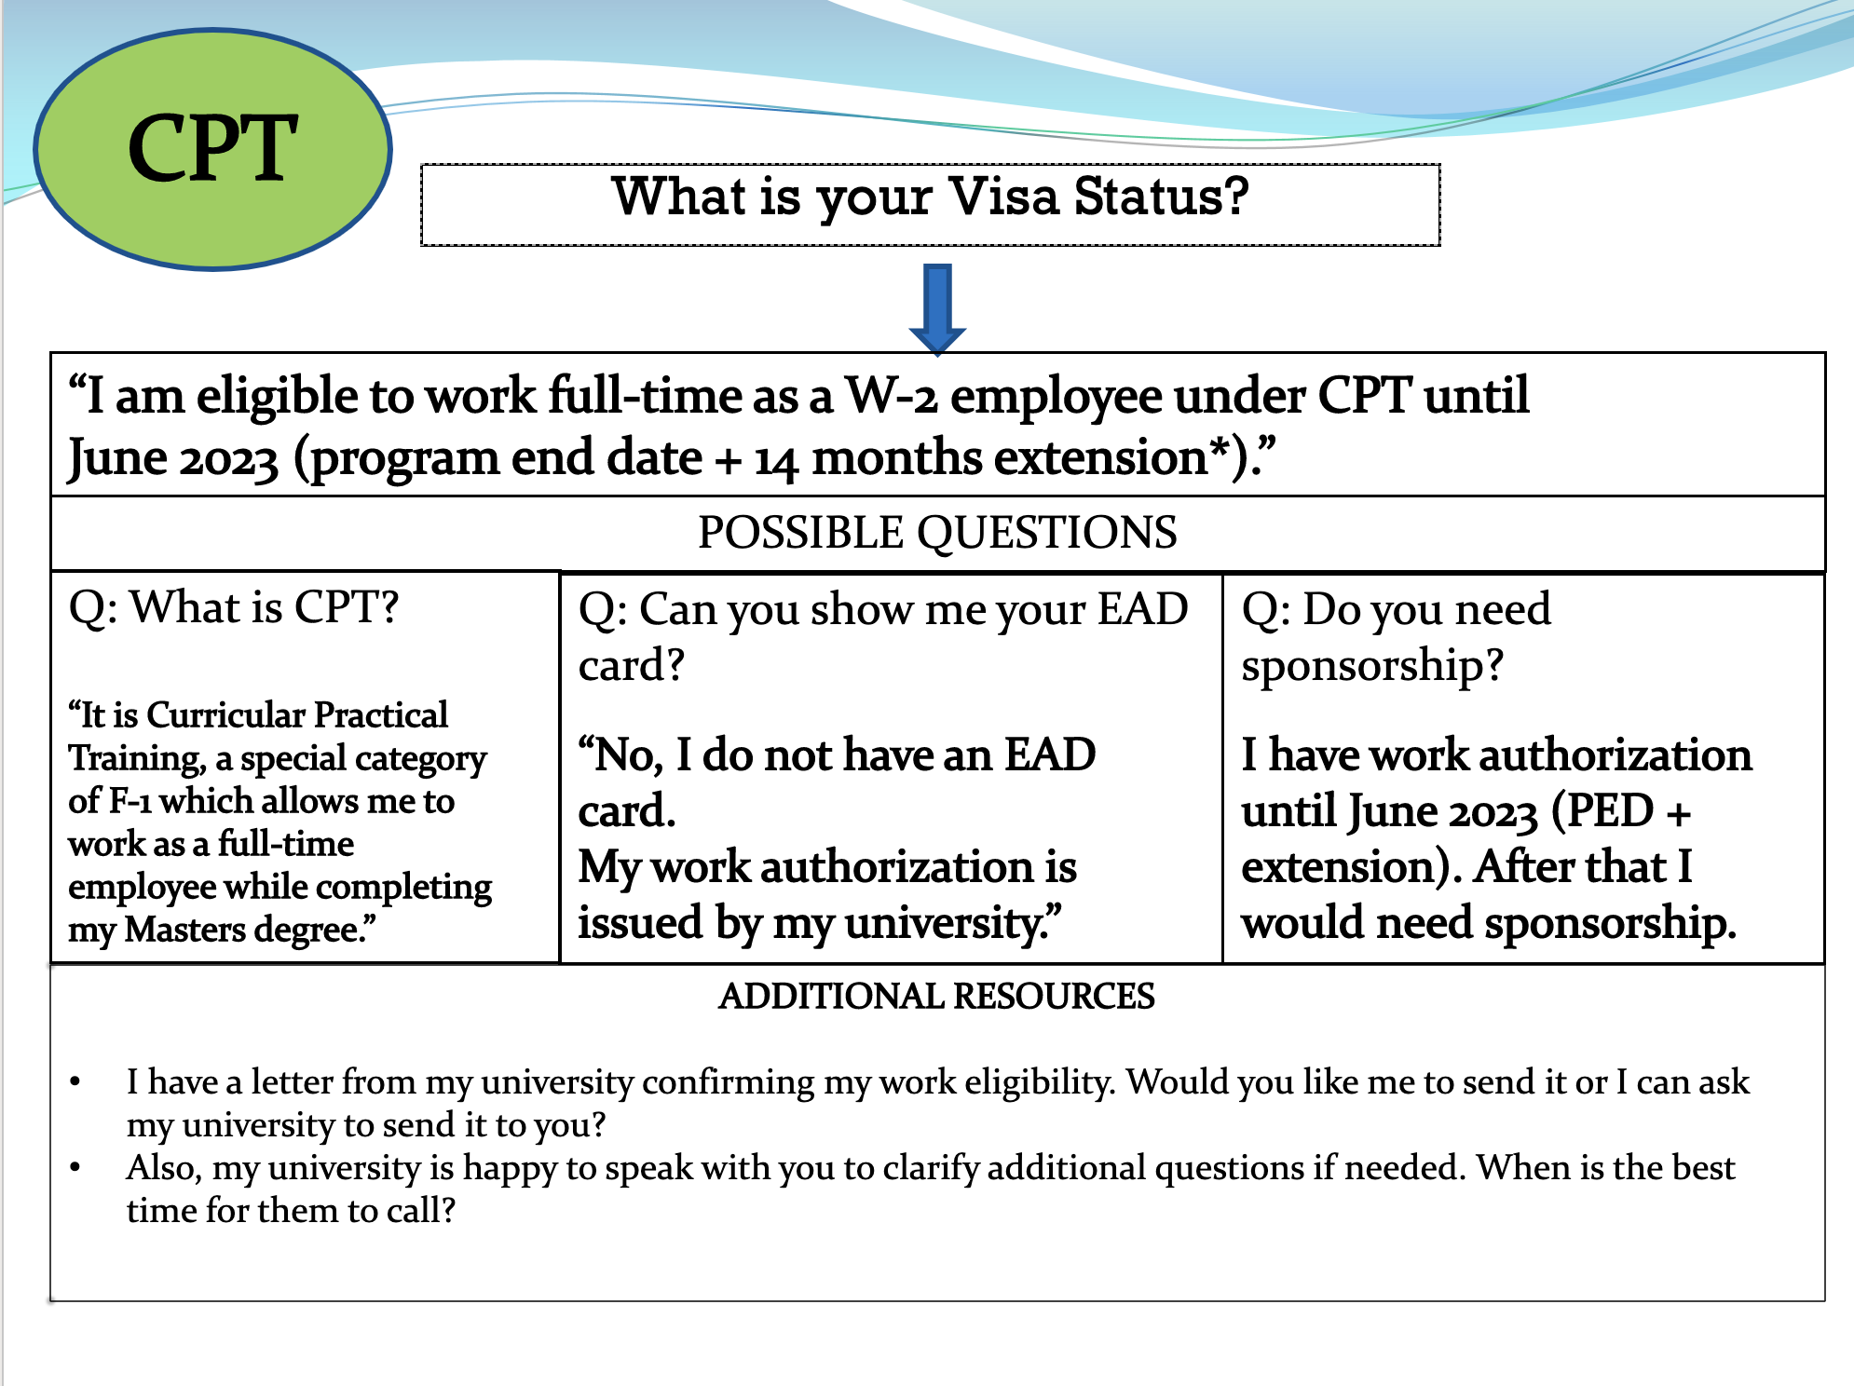

What is H1B/ GC

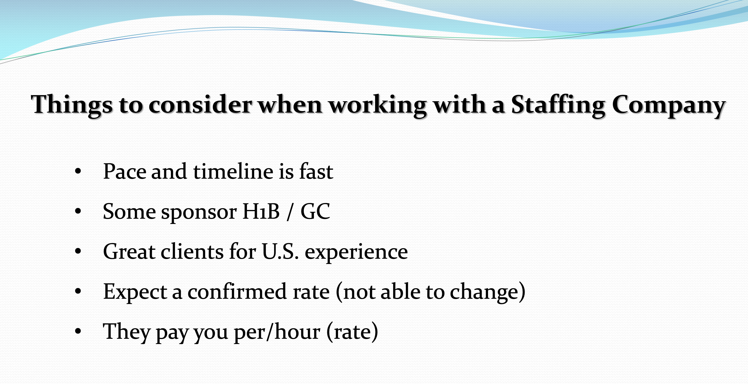

What are the minimun hours per day I can work in a company?

